|  |  |
| --- | --- |
| **Ex no : 4** | **Create charts like Bubble, Bar and Map using Tableau** |
| **Date :** |

**AIM**

To create charts like Bubble, Bar and Map using Tableau for a selected data source.

**PROCEDURE**

Step 1: Download amazon prime tv dataset from <https://www.kaggle.com/datasets/shivamb/amazon-prime-movies-and-tv-shows/>

Step 2: Import the dataset into Tableau Desktop.

Step 3: Drag the attributes to the row or column space in tableau for creating the charts

Step 4: In right side chart pane, choose the type of chart to visualize the selected attributes

**OUTPUT**

Bar Chart

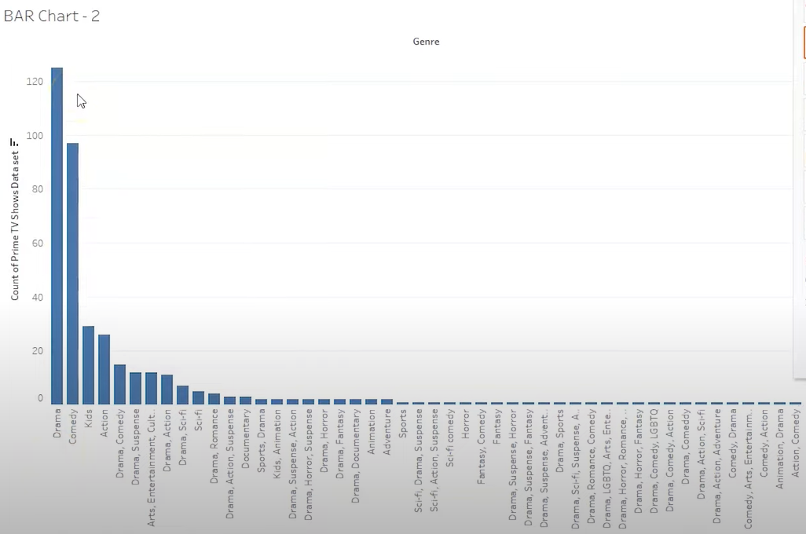

Bobble chart

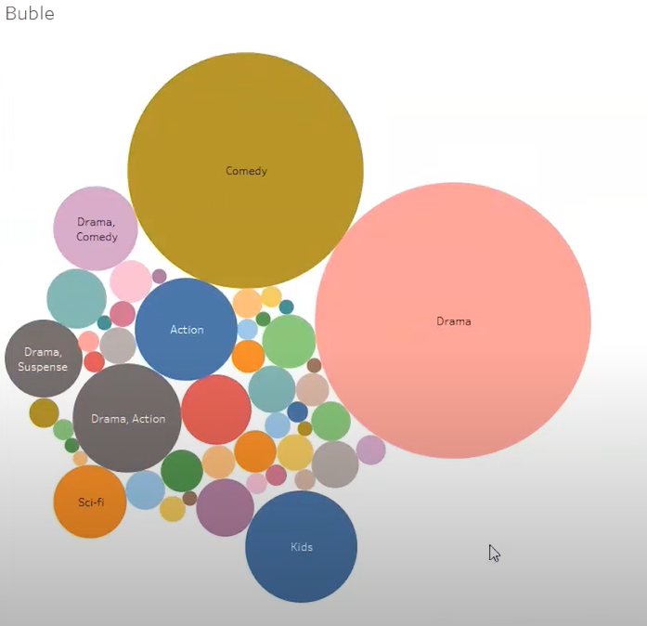

Map Chart

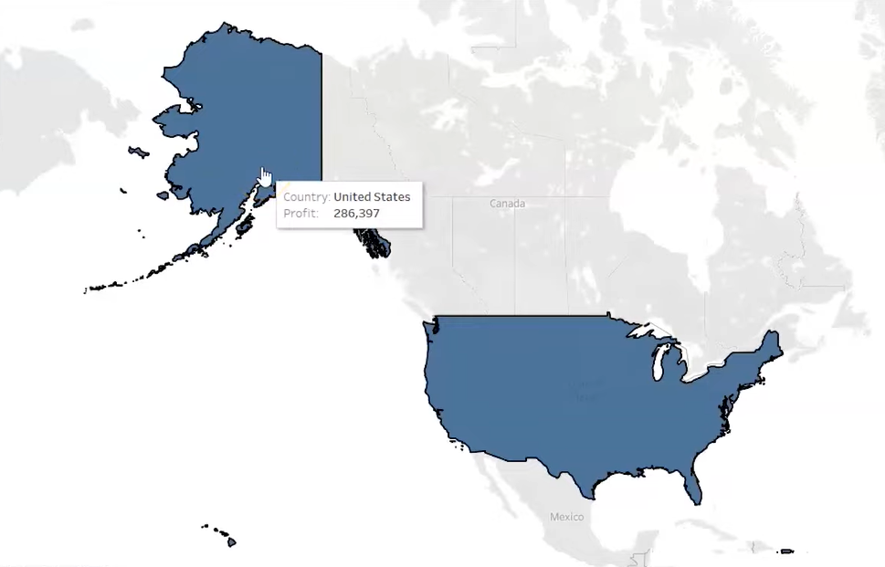

**RESULT**

Thus, charts like Bubble, Bar and Map has been built successfully using tableau.